INTRODUCTION

The Quiz Management System is a Python-based application developed with MySQL as the database. The main purpose of this project is to provide a simple and interactive platform for conducting multiple-choice quizzes.

The system contains two major sections: the Administrator Panel and the User Panel. The administrator can add new questions, display existing questions, delete individual questions, and delete all questions. The user can select the number and category of questions and attempt the quiz.

The project also contains a set of default questions covering categories such as Science, Geography, History, India, Sports, and World. Additional questions can be entered by the administrator and stored in the same database.
OBJECTIVES

The main objectives of the Quiz Management System are:
- To develop an easy-to-use quiz application using Python.
- To store quiz questions permanently using MySQL.
- To provide multiple-choice questions with four options.
- To allow the administrator to add their own questions.
- To organize questions according to different categories.
- To allow users to select the number of questions they want to attempt without repeating questions.
- To calculate user’s score.
- To demonstrate the practical use of Python with a database.
TECHNOLOGIES USED

The project uses the following technologies:

Frontend
The project does not use a separate graphical frontend such as HTML, CSS, or JavaScript. The Python console/terminal acts as the user interface.

Python is used to display menus, questions, options, instructions, scores, and messages and to take input from the user.

Backend
Python acts as the main programming language and controls the complete logic of the application.

MySQL is used as the backend database for storing and managing quiz questions.

PyMySQL is used to establish communication between Python and MySQL. The program imports PyMySQL using import pymysql as p.

The Python program sends SQL commands to MySQL through PyMySQL, and the results are returned to Python for processing.

DATABASE AND TABLE STRUCTURE

The project uses a MySQL database named PROJECT_QUIZ. The program creates this database automatically if it does not already exist.

The id field is AUTO_INCREMENT and acts as the PRIMARY KEY, which gives every question a unique identification number.

A table named questions is created inside the database. The table contains the following fields:

Field | Data Type | Purpose
id | INT | Unique identification number of each question
category | VARCHAR(255) | Stores the category of the question
question | TEXT | Stores the actual question
option1 | VARCHAR(255) | Stores option A
option2 | VARCHAR(255) | Stores option B
option3 | VARCHAR(255) | Stores option C
option4 | VARCHAR(255) | Stores option D
answer | CHAR(1) | Stores the correct option

WORKING OF THE SYSTEM

The system starts by connecting Python with the MySQL database. The administrator can manage the questions through the Administrator Panel.
The program initially inserts default questions into the database. It also provides a function through which the administrator can enter a new question, its category, four options, and the correct answer.
In the User Panel, the user enters the number of questions they want to attempt and selects a category. The program retrieves all questions belonging to that category and selects the required number of questions using Python's random module.
The user then answers the questions one by one. A correct answer gives 4 marks, while an incorrect answer results in a deduction of 1 mark. At the end, the total score is displayed.
CODEBASE

Creating a Database:

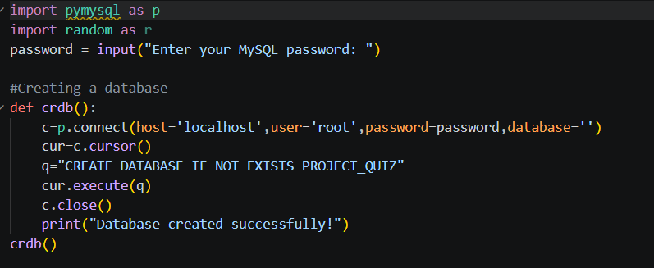

Creating a Table:

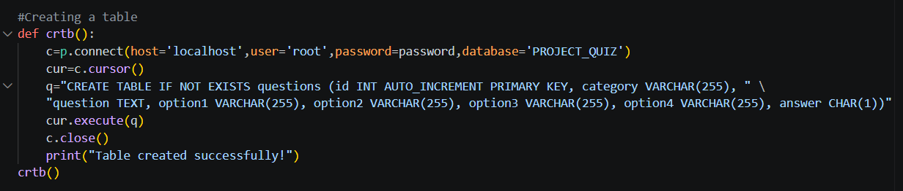

Inserting Default Questions:

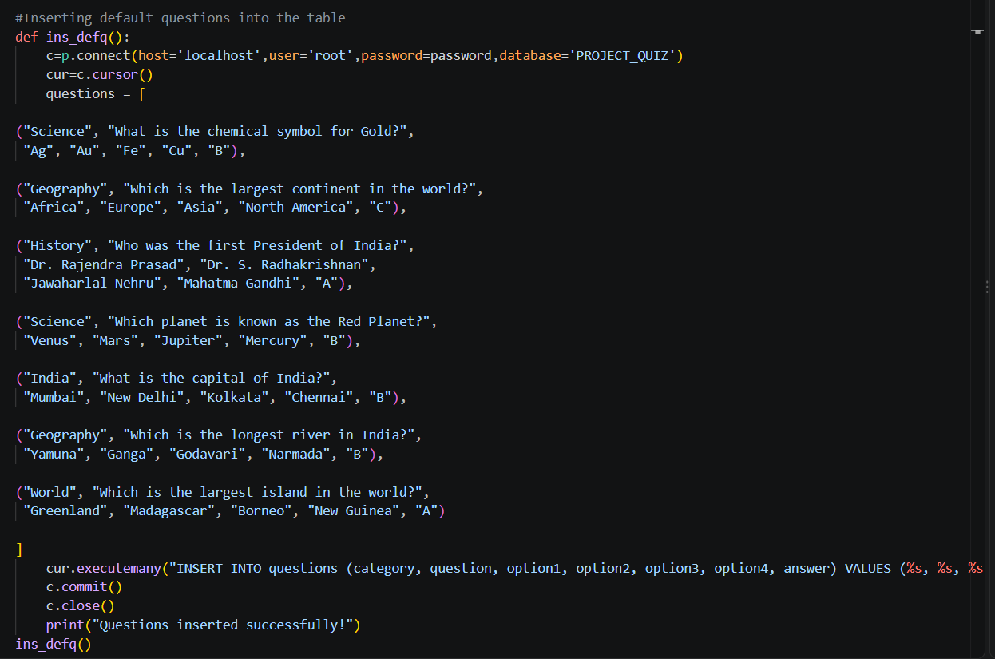

Inserting own Questions into the table:

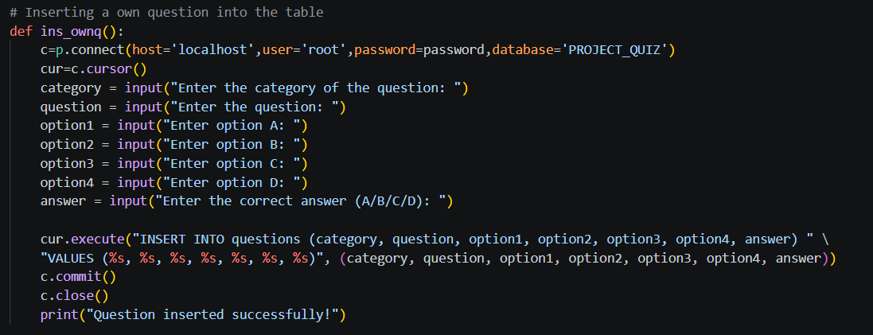

Display Questions:

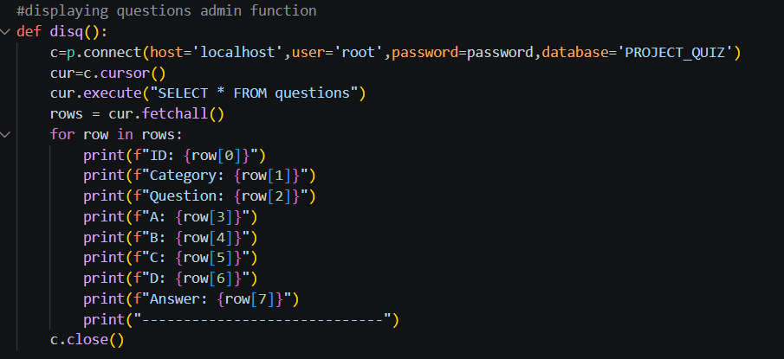

Deleting specific questions:

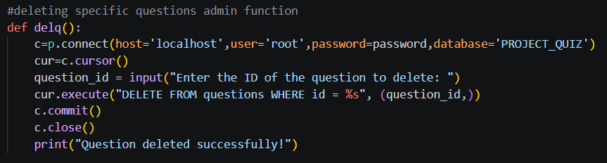

Deleting all questions:

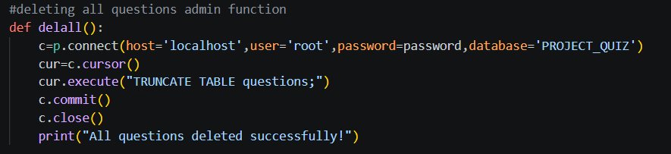
ADMINISTRATOR FUNCTION:

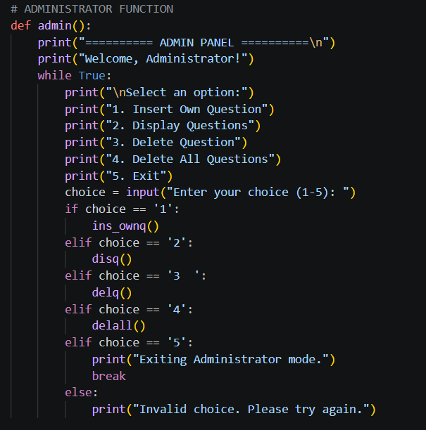

Accessing Admin Panel:

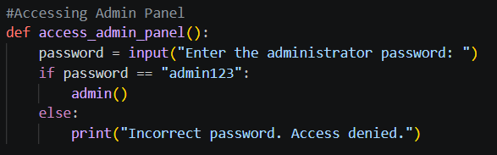

USER FUNCTION:
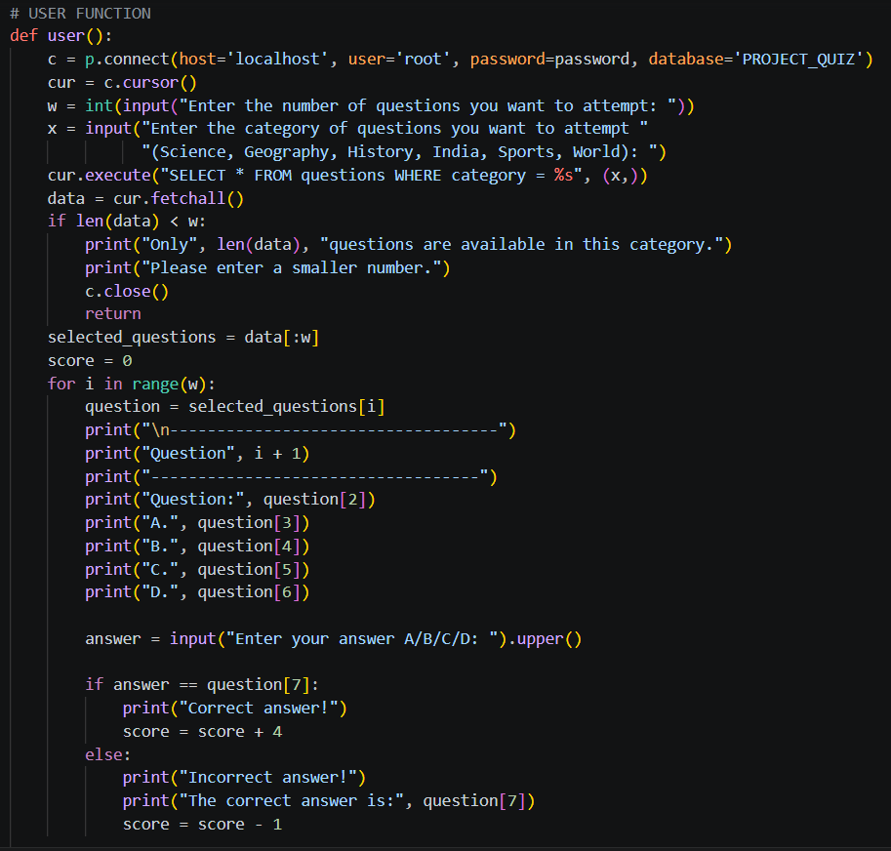
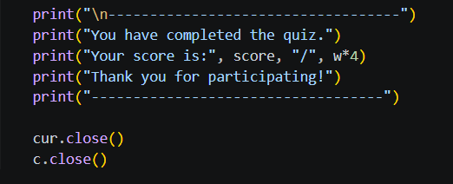

MAIN FUNCTION:

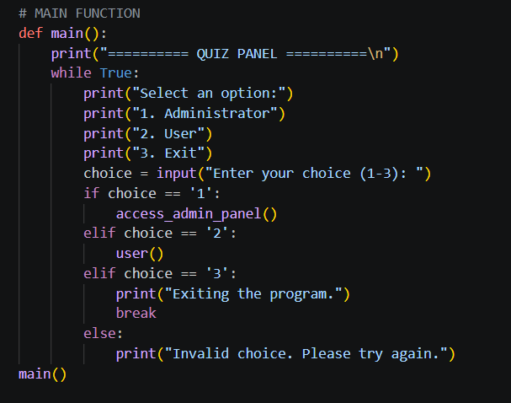

ADVANTAGES

The major advantages of the Quiz Management System are:
- Easy to Use – Simple and user-friendly console interface.
- Database Storage – Questions are securely stored in MySQL.
- Category-Based Quiz – Users can select questions by category.
- Random Questions – Questions can be selected randomly without repetition.
- Easy Management – Admin can add, display, and delete questions.
- Automatic Scoring – The system automatically checks answers and calculates the score.

LIMITATIONS

- It is a console-based application and does not have a graphical user interface.
- There is only a basic administrator password system.
- The project does not have separate accounts or login systems for different users.
- The current system does not permanently store individual user scores or detailed performance history.
- The question selection depends on the questions available in the selected category.
- The system requires MySQL to be running for database operations.
- There is no online or multiplayer quiz functionality.
- The application currently does not provide advanced analytics or detailed reports of user performance.
FURURE SCOPE

The project can be improved and expanded in many ways in the future:
Graphical User Interface
A GUI can be developed using Tkinter, PyQt, or another framework to make the application more attractive and user-friendly.
Timer
A timer can be added for every question or for the complete quiz to make the quiz more challenging.
User Login System
A proper registration and login system can be added so that different users can have individual accounts.
Score History
The scores of users can be stored in MySQL so that their previous performance can be viewed later.
Performance Analysis
Charts and graphs can be added to show accuracy, scores, correct answers, and performance by category.
Difficulty Levels
Questions can be divided into Easy, Medium, and Hard levels.
Larger Question Bank
The database can be expanded with hundreds or thousands of questions.
Online Quiz
The application can eventually be converted into a web-based application so that users can attempt quizzes through a browser.
Enhanced Security
The administrator authentication can be improved using encrypted or hashed passwords instead of a simple password stored directly in the program.

CONCLUSION

The Quiz Management System demonstrates the integration of Python and MySQL, where Python manages program logic, user interaction, random question selection, and scoring, while MySQL stores and manages the questions. PyMySQL connects Python with MySQL and enables operations such as inserting, retrieving, and deleting data.
The project demonstrates concepts including functions, loops, conditional statements, lists, user input, SQL queries, and database connectivity. Overall, it provides practical knowledge of Python–MySQL integration and can serve as a foundation for developing advanced GUI or web-based quiz applications in the future.

